Q-10-2
Correct answers marked with an asterisk (*)

1) The two graphs, A and B, show dotplots from two different data sets. Suppose I want to compare the means in A and do another comparison of means in B. For each case an F-statistic is computed. Which of the following will be true about these statistics?
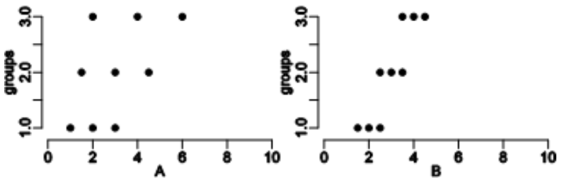
a. The F-statistic is the same in A and B.
b. The F-statistic is larger in A than in B.
*c. The F-statistic is smaller in A than in B.
d. We cannot tell if the F-statistic will be larger in A or B.

2) An experiment is conducted which randomly places students into one of three treatment groups: (1) those students who will take a test that is printed on white paper, (2) those students who will take the same test, but printed on red paper, and (3) those who will take the same test, but printed on blue paper. The researcher analyzes the data using ANOVA in order to compare the average scores in the three groups looking for evidence that the average score is different on at least one of the three tests. Assume that at least one group really is different when answering the following question.
As the size of the sample in each group increases, all else remaining the same, what will be the impact on the strength of evidence for finding a difference in the average scores on the three exams?
*a. There will be more evidence of a difference.
b. There will be less evidence of a difference.
c. There will be no impact on the strength of evidence of a difference.
d. There is not enough information to tell.

3) A British study examined whether the type of background music playing in a restaurant affected the amount of money that diners spent on their meals. The researchers asked a restaurant to alternate silence, popular music, and classical music on successive nights over eighteen days. Each type of music was played for 6 nights (the order was randomly determined to guard against confounding). The type of music played and the amount spent on food and drinks (in British pounds) for each of 393 customers was recorded. The data are summarized below.
 | Sample size | Mean | StDev
Classical | 120 | 24.1 | 2.30
Pop | 142 | 21.9 | 2.73
None | 131 | 21.7 | 3.38
Pooled | 393 | 22.5 | 2.85

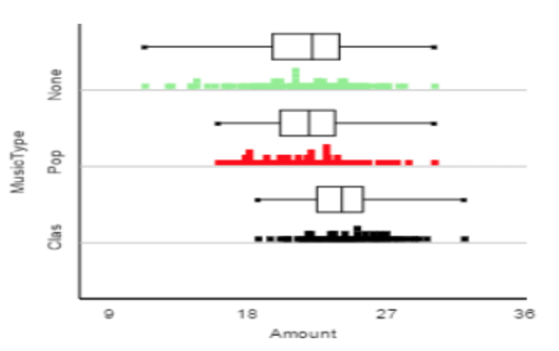
Which of the following validity conditions are met to conduct an ANOVA F-test on these data? Select the option does NOT apply.
a. The standard deviations of the sample are approximately equal.
b. The sample sizes are all at least 20.
c. The sample distributions show no strong skewness.
*d. The sample means are all at least 20.

4) A British study examined whether the type of background music playing in a restaurant affected the amount of money that diners spent on their meals. The researchers asked a restaurant to alternate silence, popular music, and classical music on successive nights over eighteen days. Each type of music was played for 6 nights (the order was randomly determined to guard against confounding). The type of music played and the amount spent on food and drinks (in British pounds) for each of 393 customers was recorded. The data are summarized below.
 | Sample size | Mean | StDev
Classical | 120 | 24.1 | 2.30
Pop | 142 | 21.9 | 2.73
None | 131 | 21.7 | 3.38
Pooled | 393 | 22.5 | 2.85

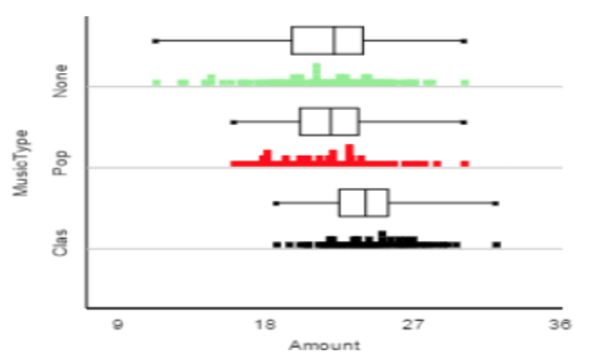
The p-value for the ANOVA F-test is less than 0.001. How would you interpret this value?
*a. In less than 0.1% of all samples, the F-statistic would be as large or larger than the one observed, assuming there is no association between music type and amount spent on food and drinks.
b. In less than 0.1% of all samples, the F-statistic would be as small or smaller than the one observed, assuming there is no association between music type and amount spent on food and drinks.
c. In less than 0.1% of all samples, the F-statistic would be as large or larger than the one observed, assuming there is an association between music type and amount spent on food and drinks.
d. In less than 0.1% of all samples, the F-statistic would be as small or smaller than the one observed, assuming there is an association between music type and amount spent on food and drinks.

5) When performing an ANOVA F-test, which definition of a p-value is the most accurate?
a. The p-value is the probability that the observed F-statistic will occur again.
*b. If the null hypothesis is true, the p-value is the probability of observing an F-statistic as large or larger than the one actually observed.
c. The p-value is the value that an F-statistic must reach in order to be significant under the null hypothesis.
d. The p-value is the probability that the null hypothesis is true.

